COS30015 Internet Security
You will need:
RedHat Linux 7.3 (VM)
A computer with internet access
Lab 11 week 12

In this lab you will perform a forensic analysis of a disk image using Autopsy/TSK

- Start VMware Workstation Pro, launch the RedHat Linux.
- After Linux finishes booting, log in as hacker (password warezwarez)
- Start the x-windows server:
startx <Enter>
- Maximise the VM window
- Launch Mozilla (old name for Firefox) 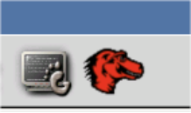

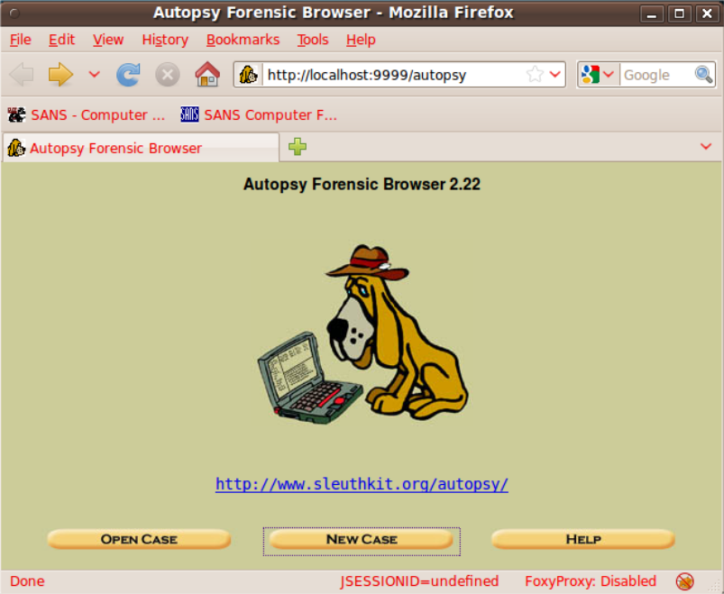

- Click New Case
- Fill in the form.

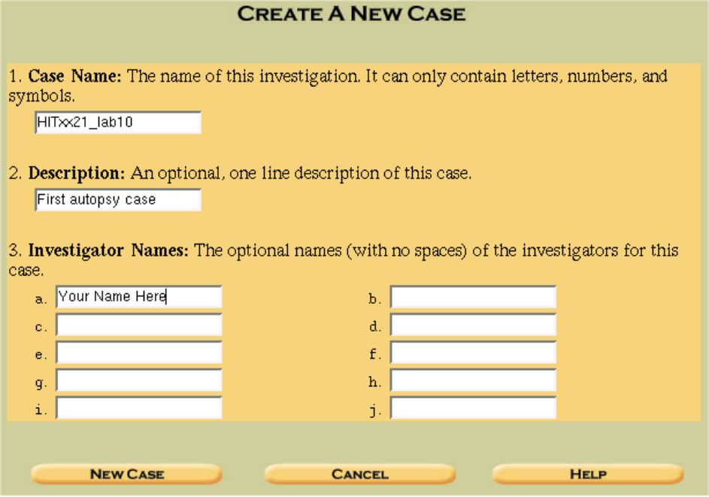
- …and click New Case
You will get a feedback message and an OK button. If the button does not appear, go back in the browser and re-submit the form.

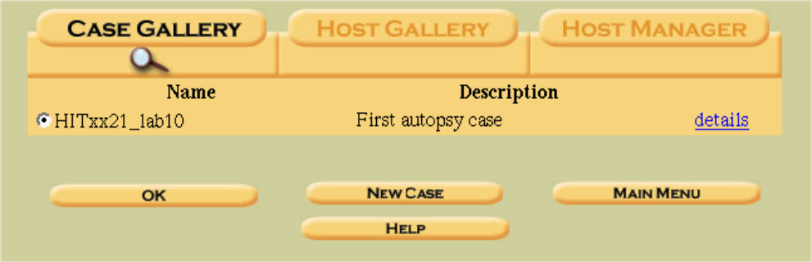
Note: many cases could appear here - select the one you have just created. (OK)

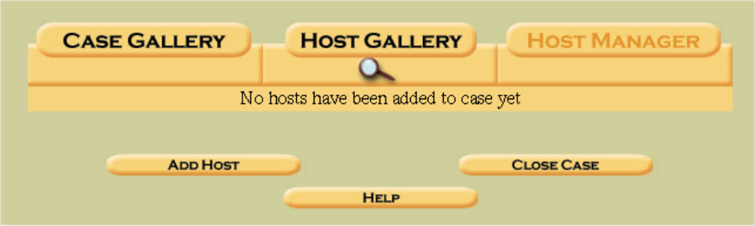
- …Click Add Host

- Fill in the form. Note that the local time is GMT + 10, so enter 10 for timezone.
The data was collected during daylight saving time, so enter 3600 (1 hour in seconds) for the timeskew setting.
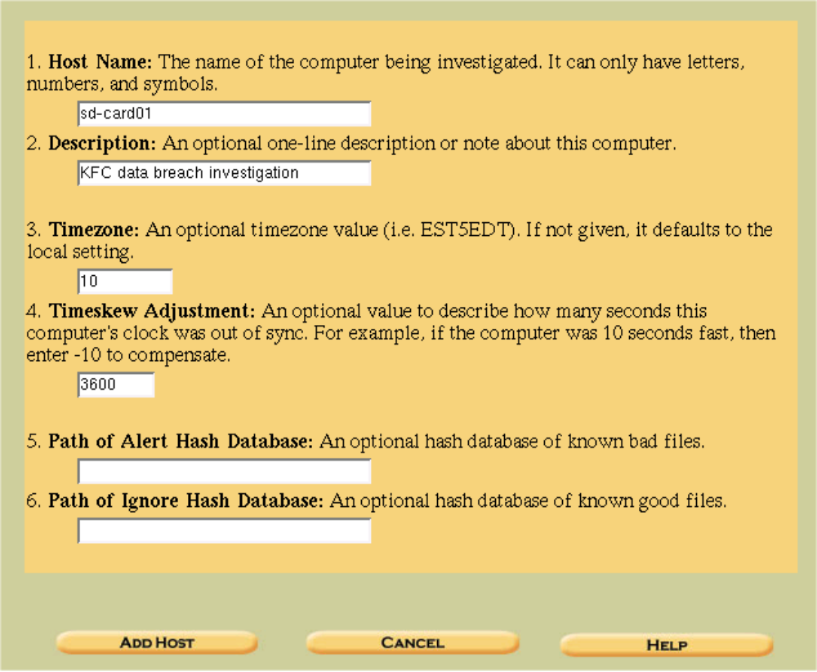
Timeskew is (for this computer) 1h == 3600 seconds (in the past)

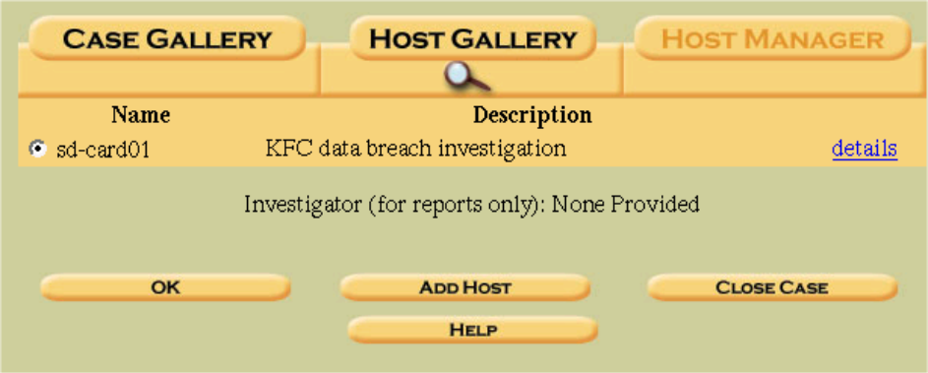
- Click on details to see data entered for this case:
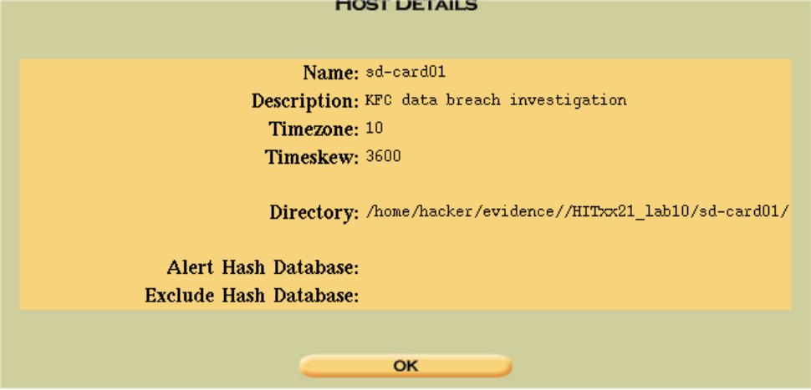

- Click OK to load the dd file into the case:
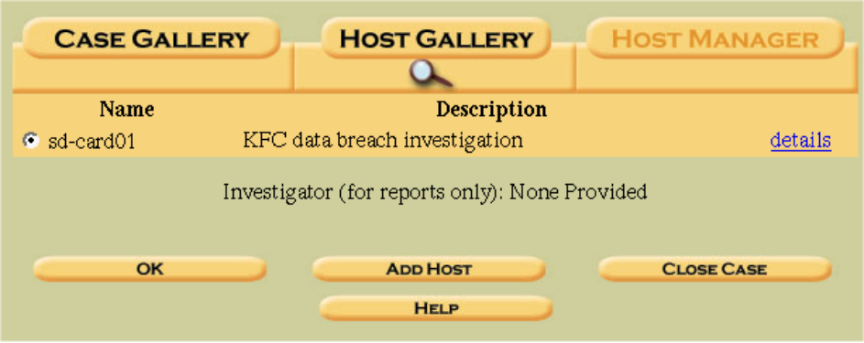

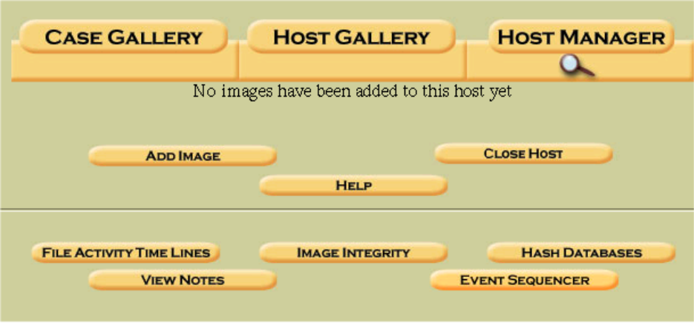
- Click Add Image

You will need the path to the disk image. To get this, open a console window

- And cd into the evidence directory:
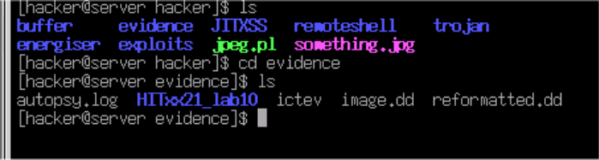

The disk image is called image.dd

Note that the path is absolute – use pwd to get the path:
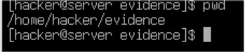
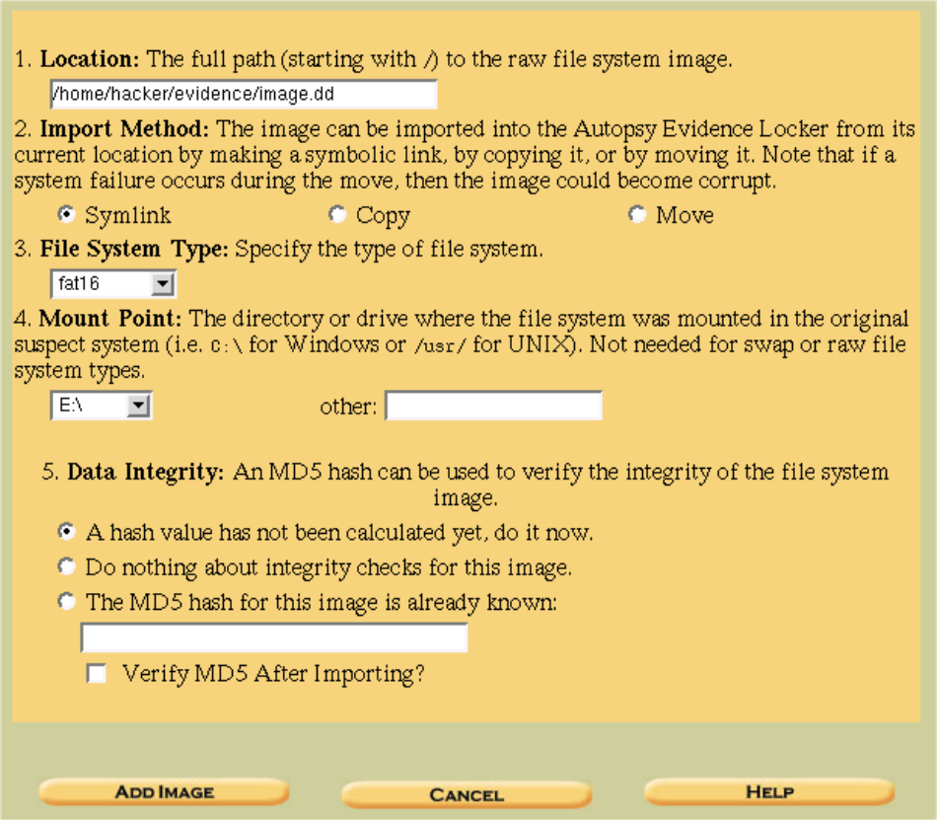
- Fill in the form as above and click Add Image

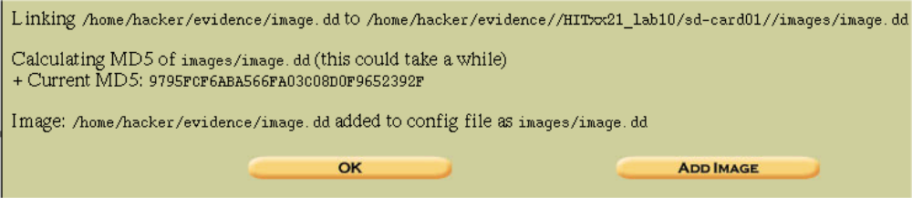

- Note the MD5 hash – you can use this later to confirm that your analysis has not altered the evidence.
What is the MD5 hash?
9795FCF6ABA566FA03C08D0F9652392F

- Click OK to continue

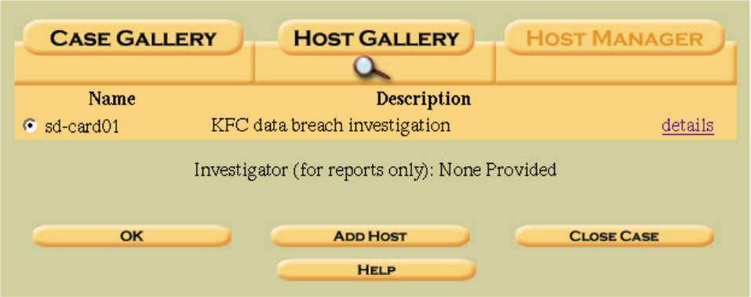

- Click on Details

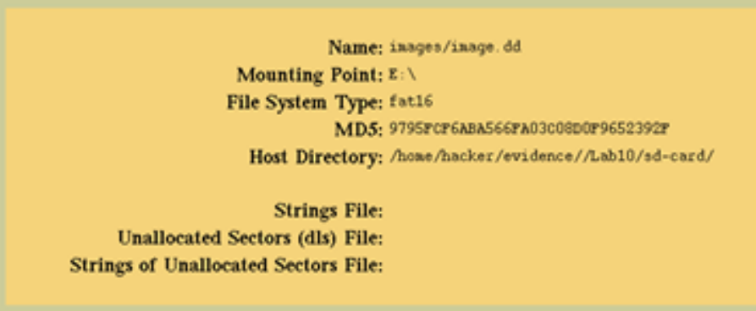

- OK to return

- OK to continue…

Now we can start the analysis.
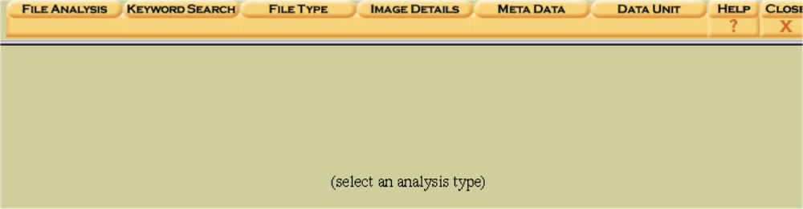
- Click on FileAnalysis
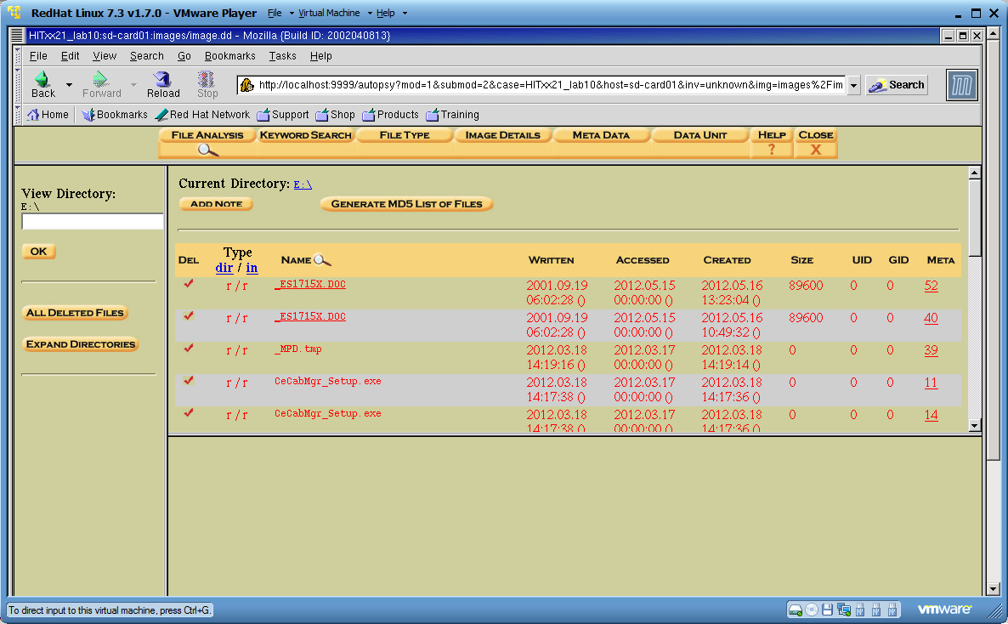

This is the file browser. You can select an underlined file (all of these have been deleted) and view its contents on the lower panel.

In the lower panel you can select the view (ASCII, Strings or Export).
Export writes the file to the hard drive (/home/hacker/) where you can view it with an appropriate viewer.

- Find the Meta value of PgI71.png.
There are two copies of the filesystem entry for PgI71.png. One is 54.
54 is actually the iNode number of this file.

To restore the file (and look at it) we need to do File Carving – Autopsy is not very good for this, so we’ll use a Linux command from the console window:

Make sure that you are in the /home/hacker/evidence directory

- Type:

icat image.dd 54 > picture.png

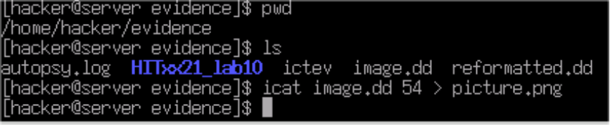

- Now switch to the desktop and click on picture.png (if needed, click on the “hacker’s home” icon, click on the evidence directory)

But the image is corrupted!

Let’s do a low-level recovery of the image.
Note that reformatted.dd is another copy of the disk image.
- First we use the console to issue the command:

xxd reformatted.dd | grep 'PNG'

This searches for the PNG file signature at the start of the file.
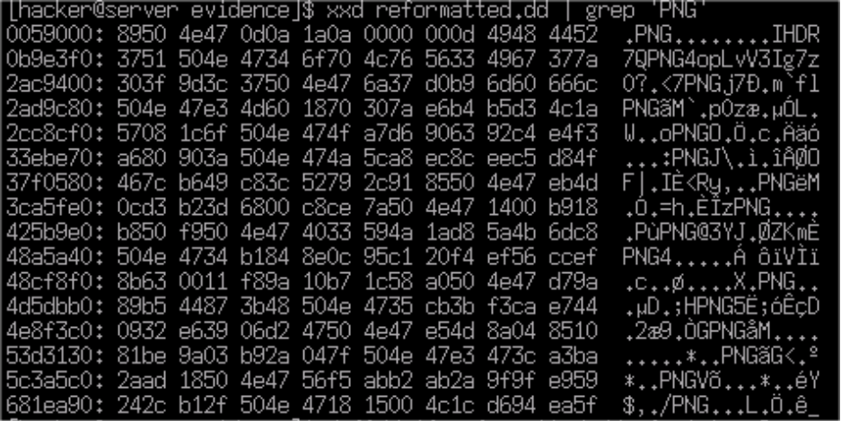

Found at 0x0059000 = 364544 \\ (decimal)

divide by 512 = 712 sectors

- Then we use dd to recover the file:

dd if=reformatted.dd of=picture2.png skip=712 bs=512 count=1000

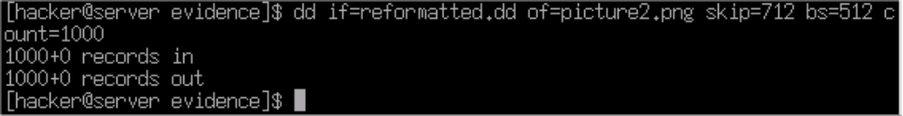
- Now switch to the desktop and click on picture2.png

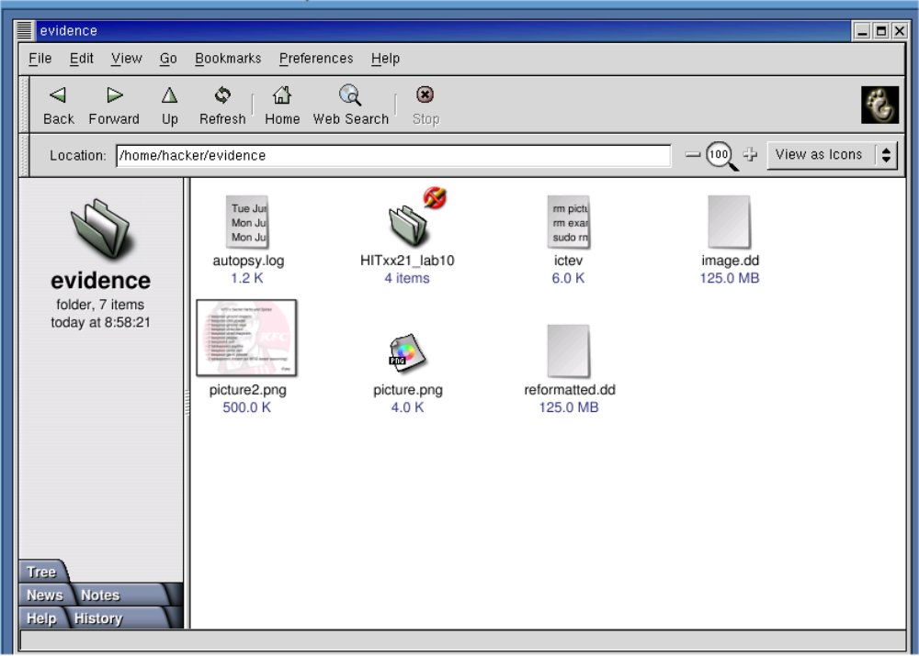

Congratulations!

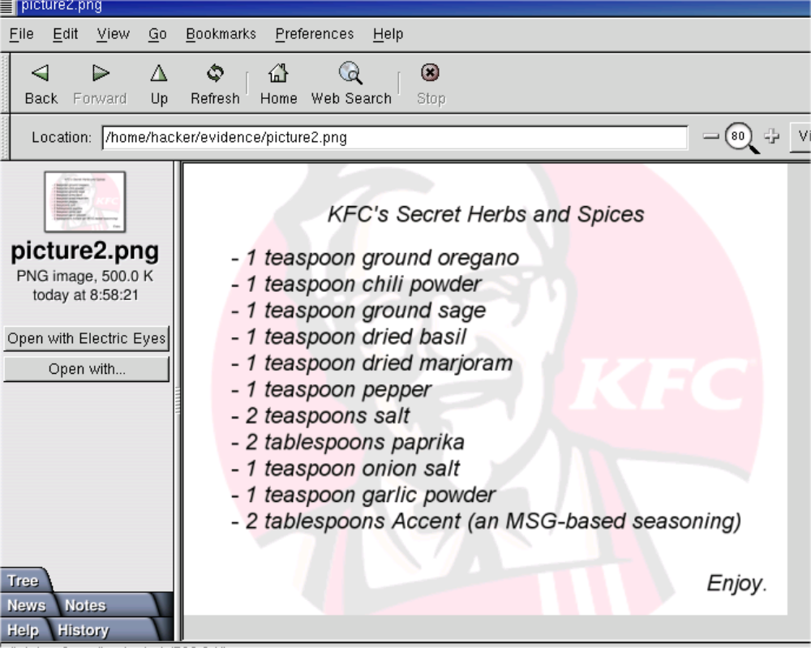
Have fun!

End of lab.

(DONE. Maybe try to see if she can go through any hackthebox type thing on that day?)

